# CS 255 System Design Document Template

Matt Smith  
04/15/2023

## UML Diagrams

### UML Use Case Diagram

### UML Activity Diagrams

### UML Sequence Diagram

### UML Class Diagram

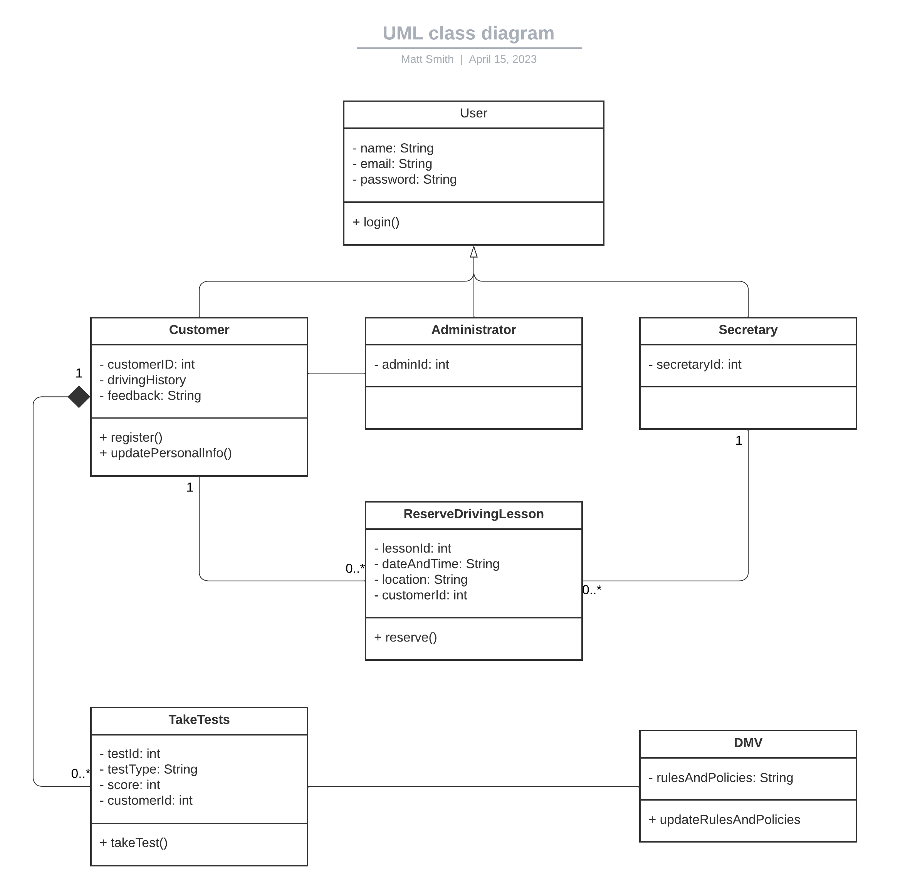

## Technical Requirements

Hardware:

* A server or servers to host the web-based application.
* Network infrastructure that’s able to handle multiple users and requests.
* PCs, laptops, and mobile devices that can access the interface for the application.

Software:

* A web development framework.
* A database system.
* A server-side scripting language.
* A client-side scripting language.
* A modern web browser.
* An operating system that’s compatible with the development framework and database system.

Tools:

* Version control software.
* An IDE for writing and editing code.
* Deployment tools for deploying the application to a cloud platform.
* Testing tools for verifying the applications functionality and performance.

Infrastructure:

* A cloud platform that’s capable of hosting a web-based application.
* A database server for storing all information.
* HTTPS encryption for secure data transmission.
* Regular backups and recover procedures for data safety and system availability.